National Chemical Engineering Conference hosted by the Faculty

Highly successful 58th Canadian Chemical Engineering Conference, held in Ottawa in October 2008 was hosted by the Department of Chemical and Biological Engineering. The conference chair was Dr. F. Handan Tezel. Under her leadership, with the help of her Vice-Chair, Mr. Bruno Morin (from Rio Tinto Alcan, in Brockville), the conference was a huge success having almost 1300 delegates attending the conference at the Westin Hotel downtown. The conference theme was “Partnerships for a Sustainable Society”. Plenary talks were given by 2 local companies, Plasco Energy Group and IOGEN Corporation. They informed delegates how their companies were working on making society more sustainable, by producing energy from garbage and by producing transportation fuel (bio-ethanol) from agricultural waste, respectively.

Technical Program was organized by Dr. Marc A. Dubé and included 5 symposia: Energy for a Sustainable Society, Materials for a Sustainable Society, Clean Water-Clean Air-Clean Earth, Industrial Biotechnology, Partnerships: Policy and Research at the Crossroads. More than 600 presentations were given at the conference.

Students were a big part of this conference with hundreds in attendance from all over Canada. Undergraduate and Graduate Student programs were organized by Dan Dicaire and Cathy Goubko, respectively, and included industrial tours as well as workshops on different topics of interest for students.

Career fair was organized for students, as well as mid-career Chemical Engineers, and on-site interviews were held during the conference. It is an exciting time for Chemical Engineers right now with a lot of local and National companies hiring in related areas.

Picture below shows most of the volunteers that helped make this conference, one of the most successful Chemical Engineering Conferences held in Canada:

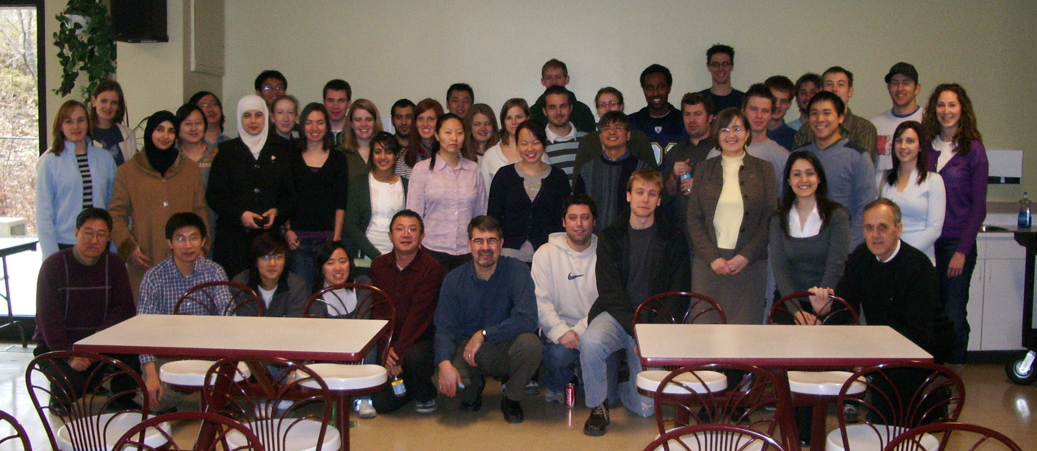

Website/More information:
http://www.csche2008.ca

